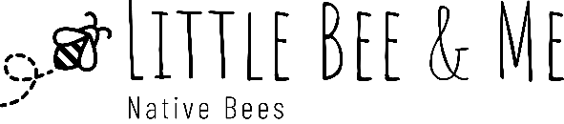
Congratulations on purchasing this boutique Bee n Bee accommodation for your native bees!

Transit
Some shifting of bamboo and timber may occur in transit. Inserts are designed to be removable so they can be replaced when necessary. Simply shuffle them back into place with gentle tapping or rearranging.
Placement
Place your bee hotel where it will be protected from the elements. Some warm sunlight is good; baking hot sun is not. Avoid rain entering the holes (sit flat or angled downwards slightly), but preferably keep it out of the rain altogether (tin bee hotels will naturally get a rustic weathered look on the outer tin but excessive moisture will make it deteriorate quickly). Boutique Bee n Bees are a piece of art. Whilst they are painted with external paints, placing it in a protected spot will increase the longevity of the artwork.
Avoid high traffic areas as this will discourage bees. Hotels can be attached to fences, deck railings or under the eaves. It is preferable to have it off the ground in order to deter ants (or place Vaseline, or similar, around the base where the ants make their entry). The bee hotel may need to be cleaned out annually: remove and replace sticks as necessary.
Inhabitants
The likely inhabitants of a bee hotel will be native solitary bees (Hylaeine bees such as masked bees, Megachilid bees such as leaf-cutter and resin bees, and Xylocopinae bees such as reed and carpenter bees). However, other insects will also utilise the space. Insects that will happily co-habit include wasps, beetles, flies, and lizards. Please understand that your bee hotel provides a safe place to hide, shelter, and reproduce in. It allows you to observe insects in your area, not just the native solitary bees, so please permit the other insects (except ants) to co-habit. If you feel you cannot welcome spiders or wasps, you might fill the holes with disposable tubes (such as paper straws or bamboo), which can be easily removed if the unwelcome ones take up residence.
Enjoy your bee hotel!

